**10 Rook Lane, Frome, BA11 1DF**

**Issues reported:**

Loose front door frame and masonry. Dangerous external balustrading to the patio.

**External observations:**

1-The main entrance door has reconstructed stone jambs to the perimeter, these are loose to both sides with evidence of previous repointing and repairs. The door has also dropped due to the loose frame. The stone sections are salvageable, the external letter flap is missing and the weatherboard requires refitting (salvageable)

2-There is a timber panelled fence acting as a guard rail to the rear patio although secure this is low, only 900mm above the patio. The corresponding post and rail timber handrail to each side of the flight of steps are also low at 800mm with gaps to the balustrade able to pass a 100mm diameter sphere. These elements do not comply with the building regulations part K and are considered a hazard due to the steep bank below in excess of 30 degrees.

**Repairs required:**

1-Remove the reconstructed stone jambs entirely from both sides of the main entrance door, rebuild with stainless steel screw on wall ties at 300mm vertical centres to both Stone face and across the cavity to the air leaf behind the cavity closer. Repoint with matching mortar and replace the frame perimeter sealant with a polymer type.

2-Replace the timber panel fence with minimum 1050mm high panelled fencing or equivalent Kee Klamp type with meshing. 10LM balustrade to the patio

6-Replace the timber handrail to the external steps with minimum 950mm high panelled fence with no gaps or equivalent Kee Klamp type with meshing. 6LM in total

**Photos:**

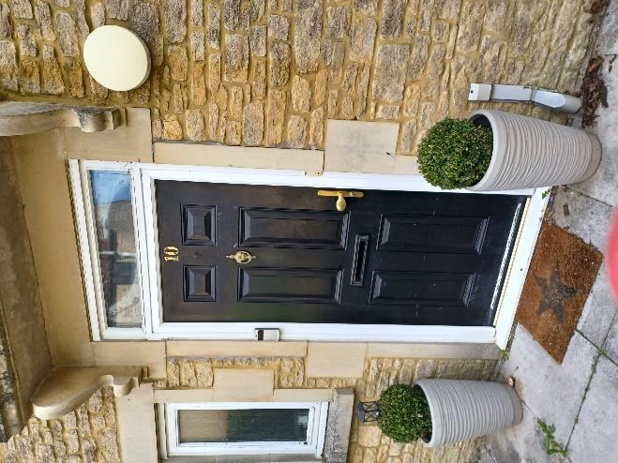 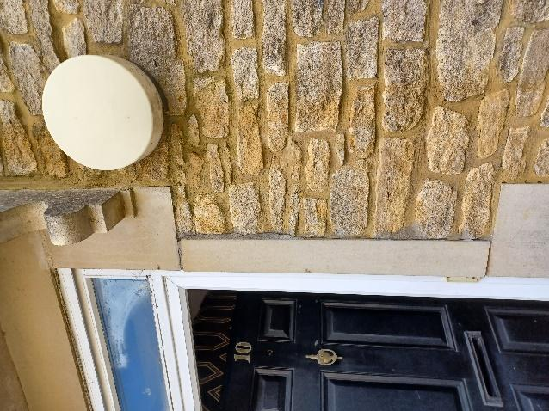

Loose reconstructed stone jambs, main entrance

Decayed French door threshold, loose stormguard and twisted frame

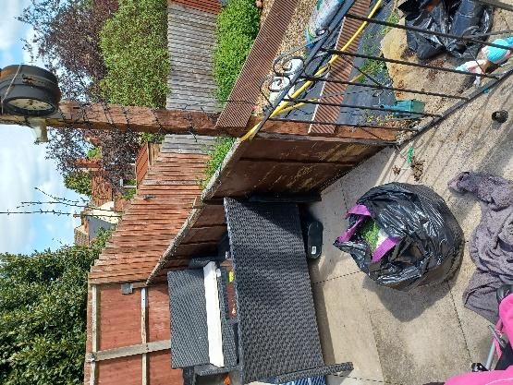 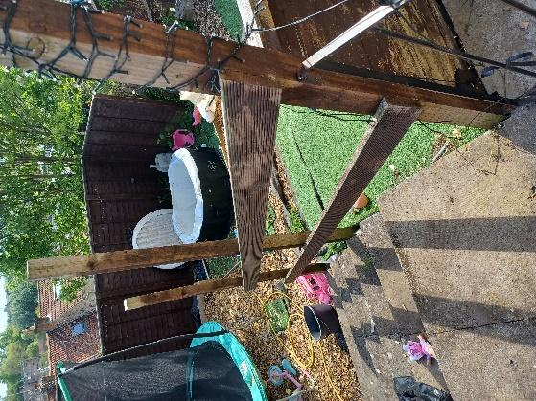 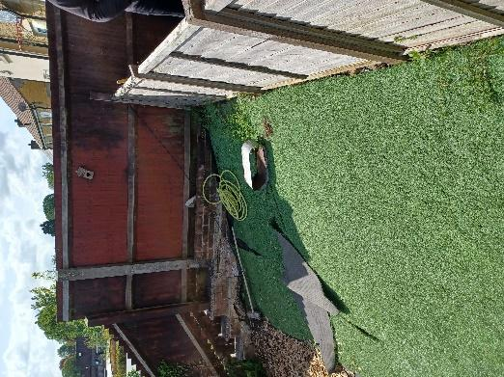

Low, incomplete balustrade and handrail, patio