**16 Allans way, W-S-M BS24 7GZ**

**Issues reported:**

1-Loose GRP parapet capping and Ridge tiles

2-decoration required to porch support post

3-mould growth issues to the first floor

**External observations:**

1-A brick faced timber framed property, pointing in satisfactory condition and DPC of satisfactory height above GL.

2-The concrete interlocking roof tiles are secure, the LED well detailed to the parapets these finished with a GRP clip on coping. the coping to the left as viewed from the front of the property is in satisfactory condition and secure. the coping to the right is mainly missing the top section this is within the property and salvageable, the connecting timber battens decayed and screws corroded securing this. This corresponding with minor water staining within the roof space to the party wall and trusses. The Ridge is mechanically fixed mostly secure however one section is missing and will require replacement the remainder should be checked for security of fixing.

3-The customer stated her son has fitted an external vent and grill to connect a portable air conditioning unit within the front bedroom. the grill is very close to the window frame however structurally sound as the timber framing to the opening is untouched. this will however require intrusive inspection to ensure an internal sleeve is fitted to prevent condensation issues due to the damaged the VCL.

4-The PVC soffits and fascia are mostly satisfactory however, the joint trim missing from the rear elevation soffit. there is no ventilation provision to these however over facial ventilators are evident with eaves guards fitted and not blocked.

5-The low level pitched roof of the porch is supported by a timber post, this separated from the ground and is satisfactory however there has been no decoration since constructed and the post is at risk of decay. Due to the design of the large eaves there is a slight bow to the porch not considered structurally significant however the gutter does require adjustment to prevent overflowing.

6-The timber double glazed windows are well sealed and operational with no issues reported however the decoration is in a poor condition to the first floor front elevation due to exposure and is at risk of decay.

**Internal observations:**

1-The bathroom has been refitted with plastic panelling to the wall and the bath removed and replaced with a low level resin shower tray. there are no issues evident or reported however there is no extractor fan fitted this corresponding with reports of reoccurring mould growth. An extractor fan fitted with a humidistat sensor required this can be ducted with insulated flexible duct to the rear elevation soffit terminated via a grill.

**Roof space:**

1-vapour permeable under felt is in satisfactory condition and vented at the Ridge however some limited mould growth indicative on the surface due to condensation this likely due to the blocked ventilation paths due to customer storage and lack of bathroom extractor fan.

2-The customer has laid timber decking to the majority of the open web of the Truss is this has resulted in compressed insulation and is a factor in the mould growth reported this should be removed by the customer and once removed the insulation relayed to at least 270 mm thickness.

3-The customer has carried out an alteration by fitting a loft hatch with integral wooden ladder. due to the size the customer has cut through a trust therefore damaging the structure of the roof. this will require additional bracing to prevent distortion of the Trusses.

4-The redundant roof tanks are Located on a substantial tank stand. These tanks should be removed to increase ventilation provision however the tank stand is considered advantageous as providing some support to the now weakened trusses.

5-There is a PIV system fitted this is operational the duct was loose due to customer storage this has been refitted however servicing of the filters is required. This corresponding with the mould growth reported.

**Conclusion:**

Exposure and poor choice of materials have led to windblown damage to the copings and Ridge.

Lack of external decoration will put the timber elements at risk, particularly to the front exposed northerly elevation.

The customer's many alterations internally do not have permission and are considered a maintenance risk however the structural damage to the roof trusses, laying of decking and a check for a sleeve to the front bedroom vent must be addressed for structural/ damp and mould purposes.

**Repairs required:**

1-Inspect the vent to the front bedroom to ensure a sealed sleeve is fitted to prevent condensation reaching the timber frame structure due to the breached VCL

2-Redecorate the front first floor windows externally and porch post.

3-Adjust the porch gutter and bracket to prevent gutter overflowing

4-Erect scaffold to both elevations, reset the GRP coping (salvageable) complete ensure this is sealed with a polymer sealant to the joints and fitted with treated BS5534 roofing battens and stainless steel screws only. Approx 10LM

5-Refix and replace missing section the entire mechanical Ridge.

6-Service the PIV with replacement filters, insure the duct is clipped satisfactorily to the unit.

7-Fit an Envirovent filterless extractor fan with humidity tracker to the bathroom ceiling, fit insulated flexible duct and terminate in the rear elevation soffit via a grill.

8-Replace the missing rear elevation soffit trim

9-Once the customer has removed all of the decking within the roof space the loft insulation should be reinstated to 270 mm thickness (approximately 9 square metres)

10-Remove the redundant water tanks from the roof space leaving the tank stand structure in place.

11-Fit additional brace to the truss web of the truss which has been cut following fitting of the loft hatch. ensure a minimum 150 x 45 mm brace is bolted with square plate washers to reinforce.

**Photos:**

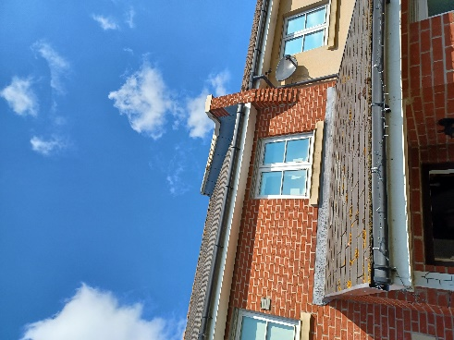 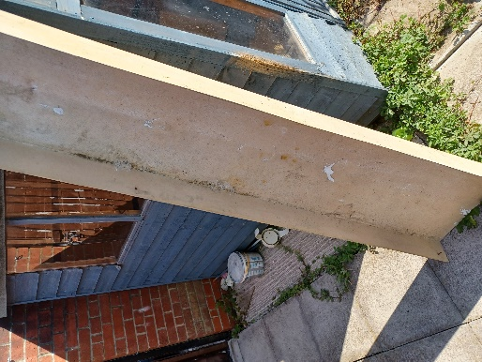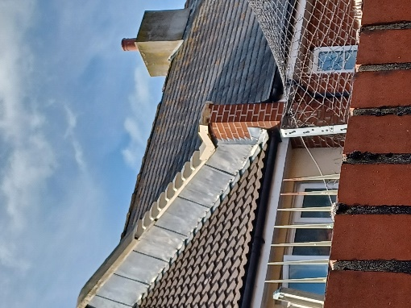

GRP copings loose to front and rear, salvageable

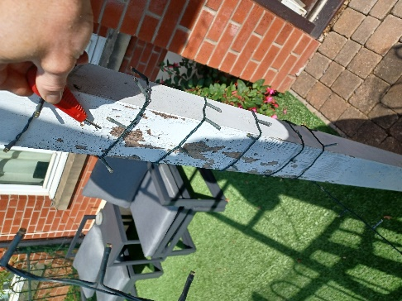 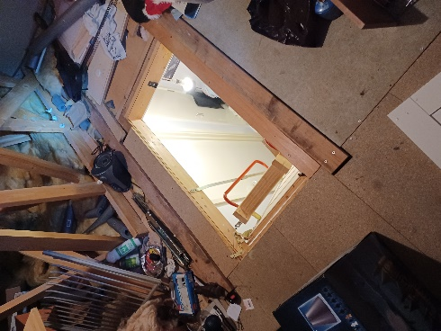

External redecs required Loft hatch and damaged truss