17A Robertson road
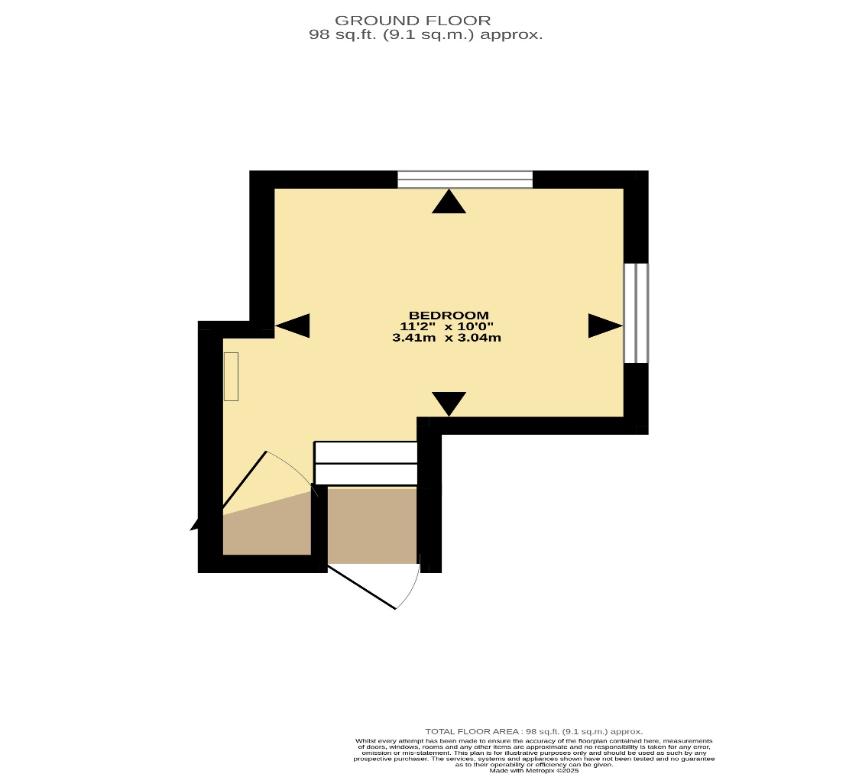

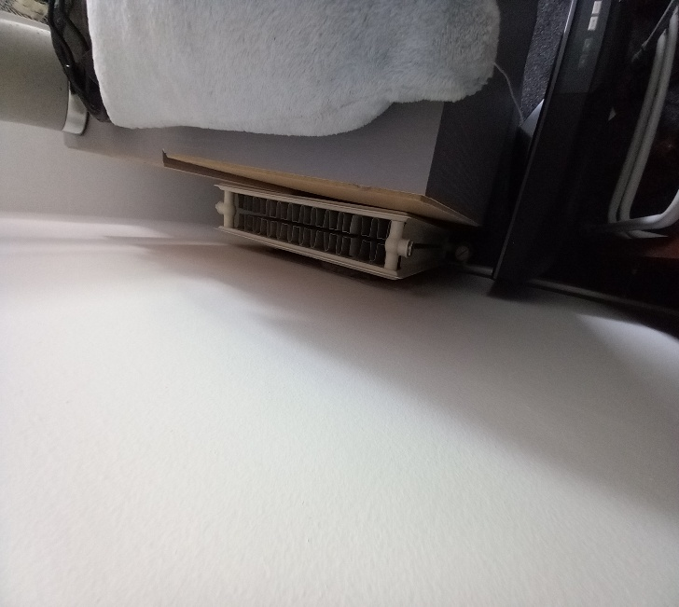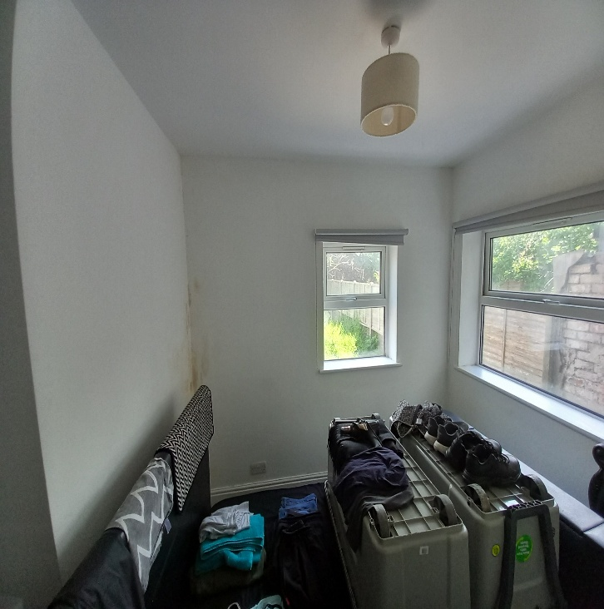
- Relocate radiator from west wall to east side wall below window, replacing the rad with a single 1000x600 to allow room to pass by. Pipework is currently in 15mm copper pipe.

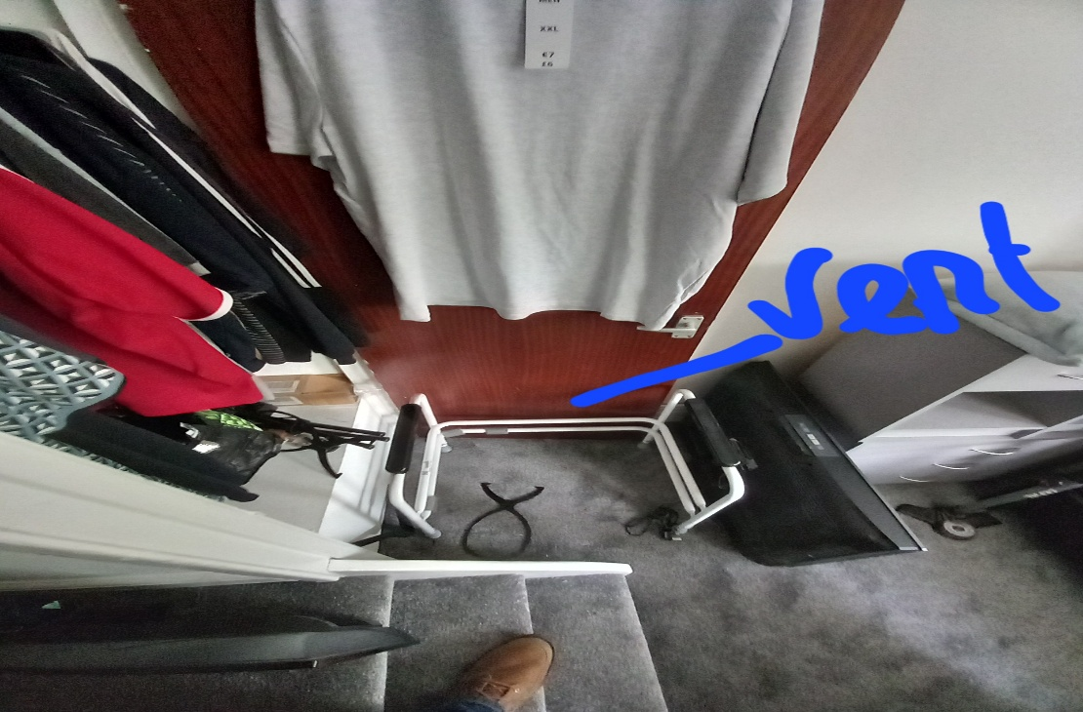
- Install Hit&Miss vent into cupboard door.

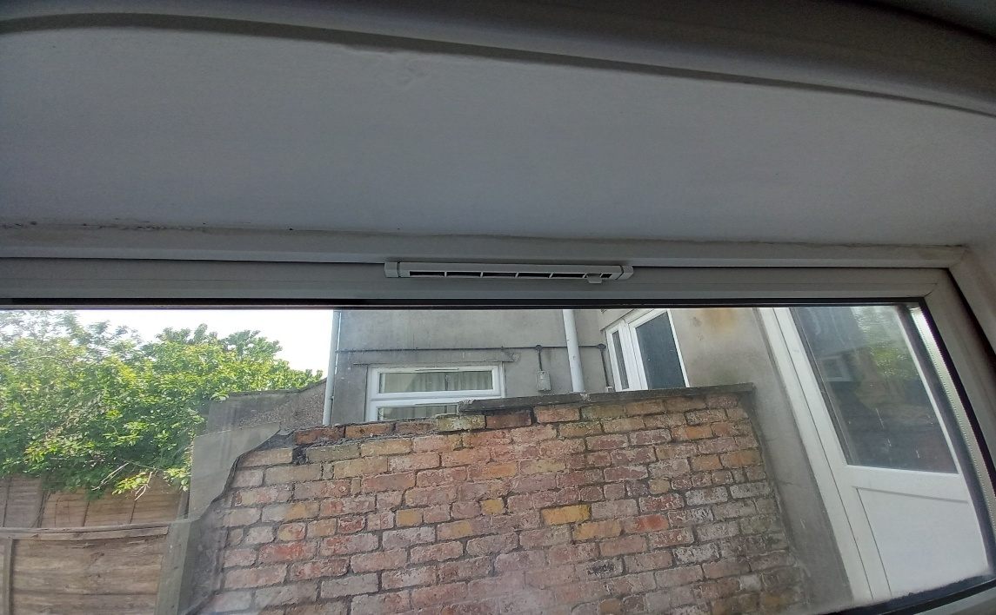
- Increase the size of the trickle vents on both casements (currently 260mm)

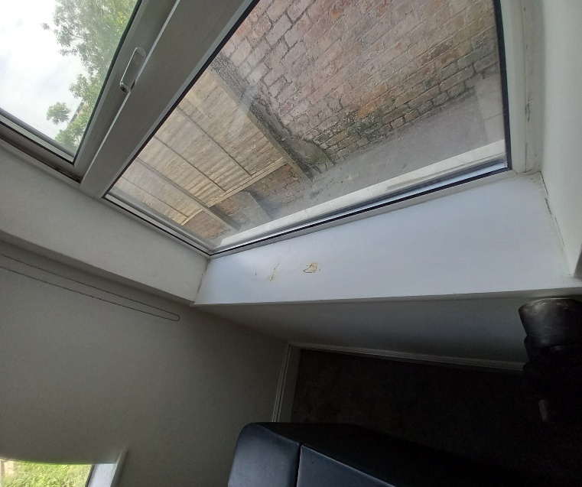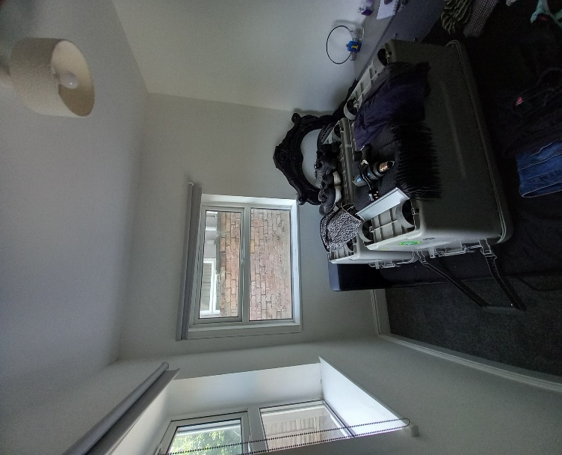
- Overboard cills with UPVC (north size opening 810mm) (east side opening 1230mm)
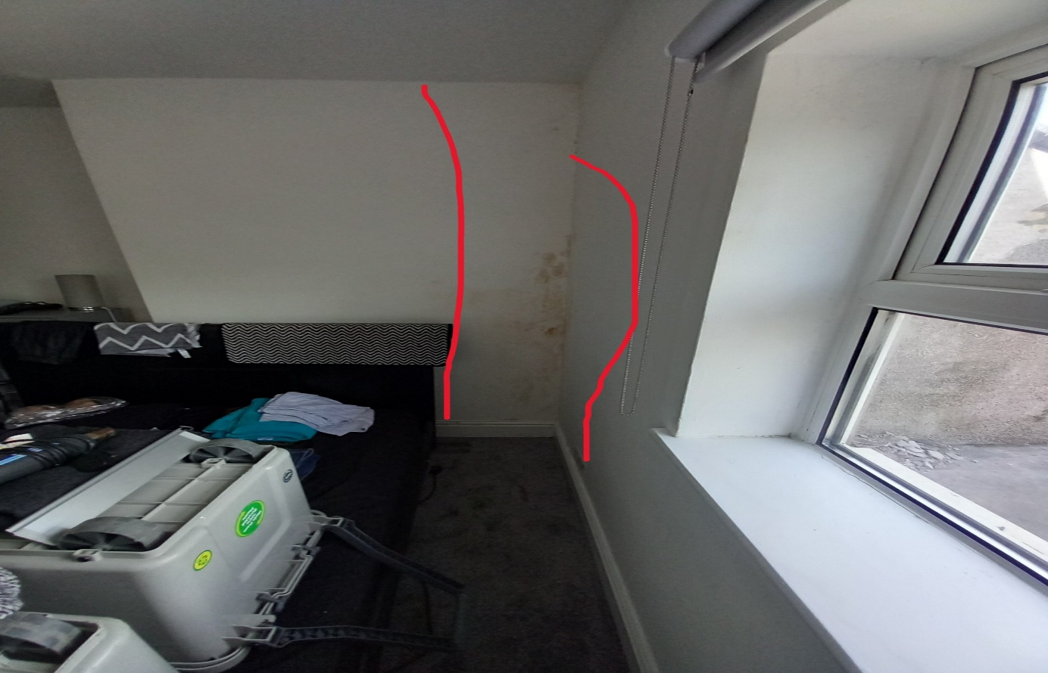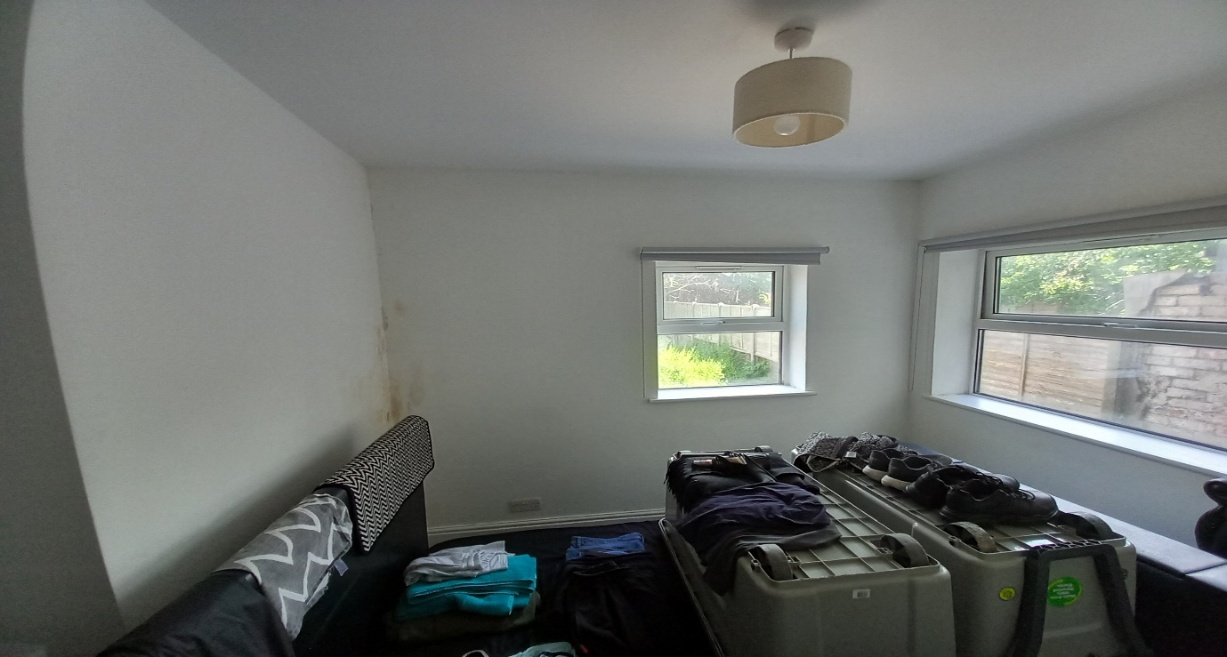
- Remove defective plaster/ plasterboard and replace with new including reskim and plasterboard. (Approx. 4sm) I believe that this construction is solid wall so the north wall may be insulated on the internal side.
- Prepare and redecorate complete room, walls, ceiling and woodwork.

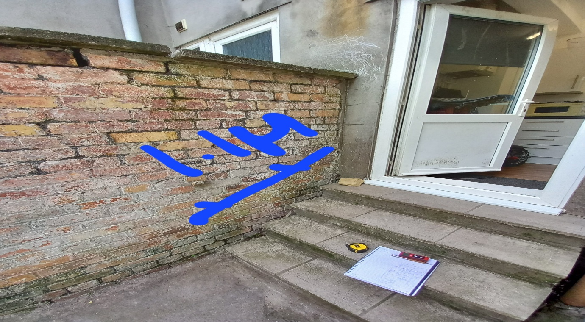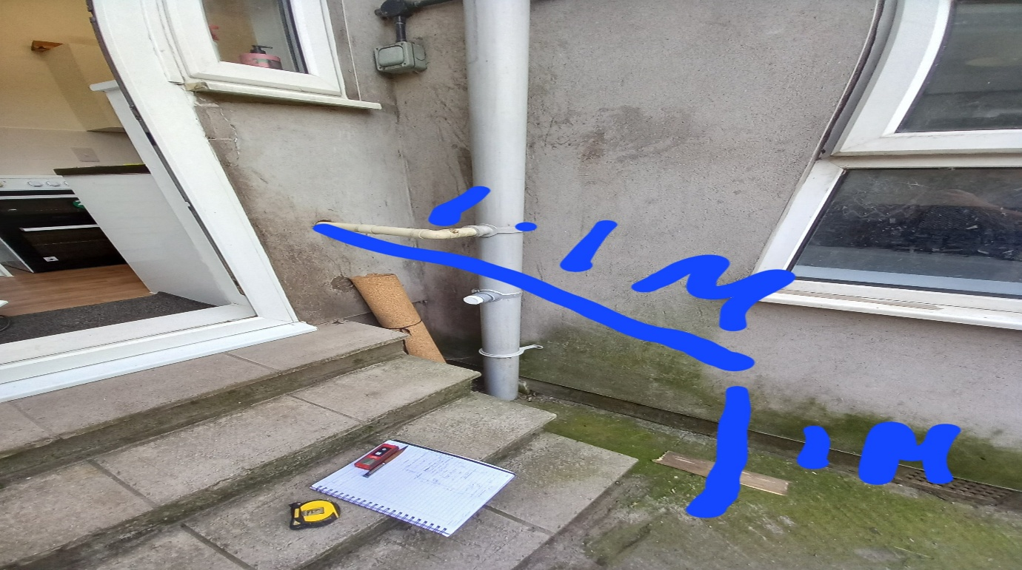
- Install key clamp handrail

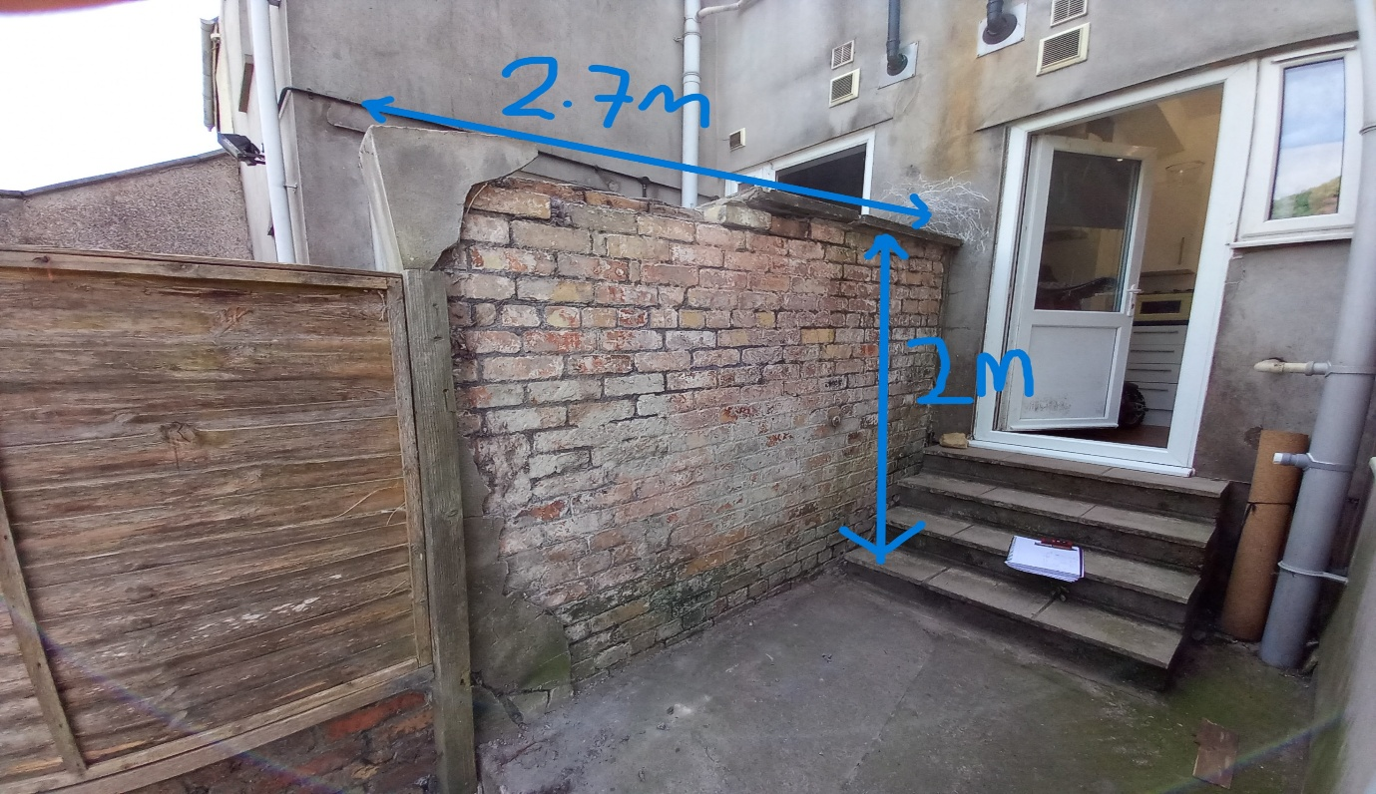
- Remove all defective and damaged render to both sides.
- Rebuild loose brickwork ( approx. 1 course)
- Prepare and apply render finish.
- Replace coping stones (360x600)

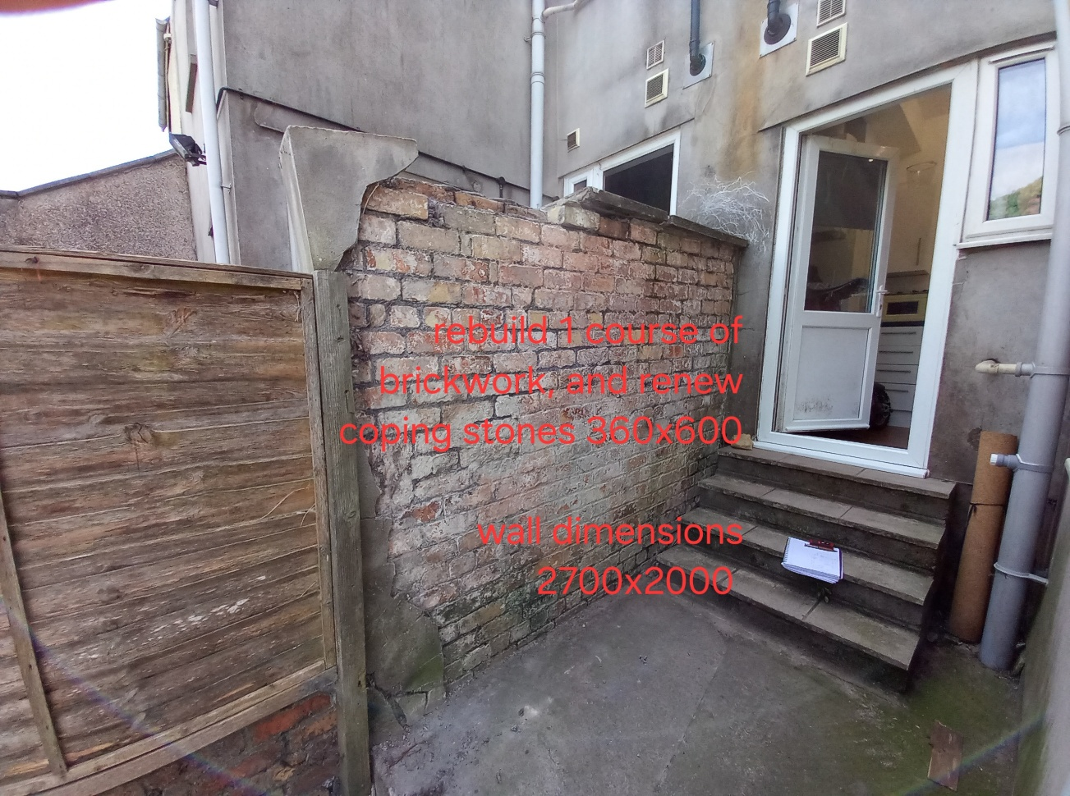
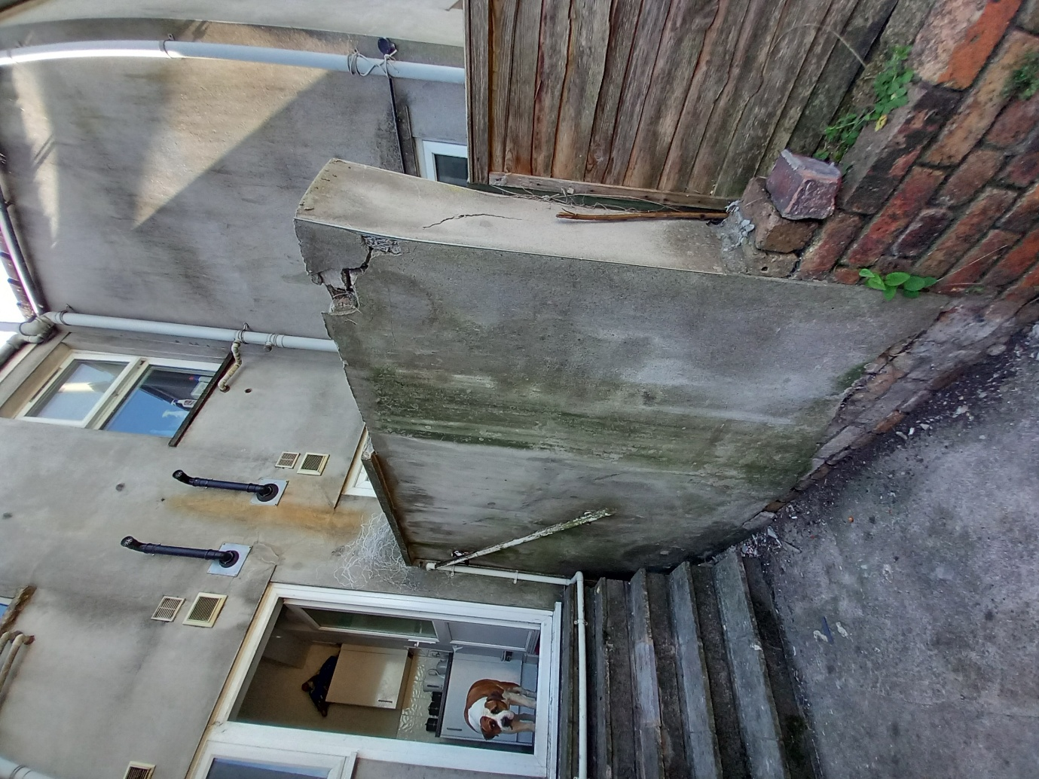
(Neighbouring property side)

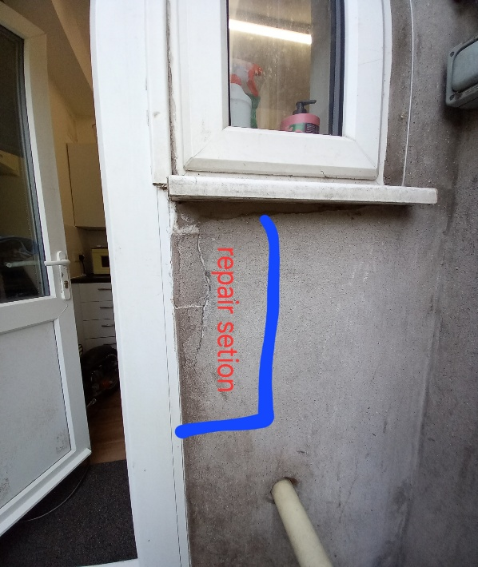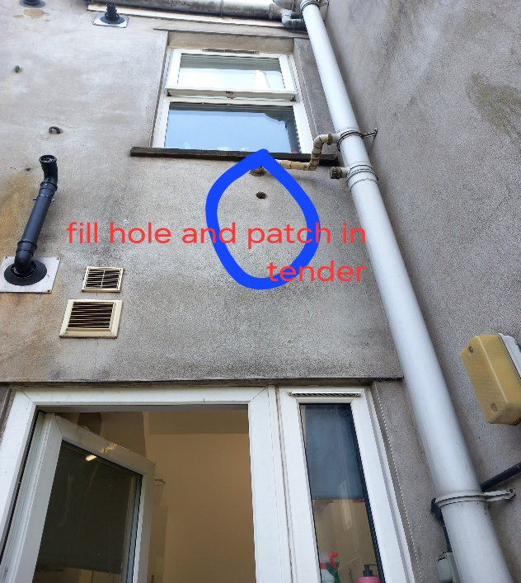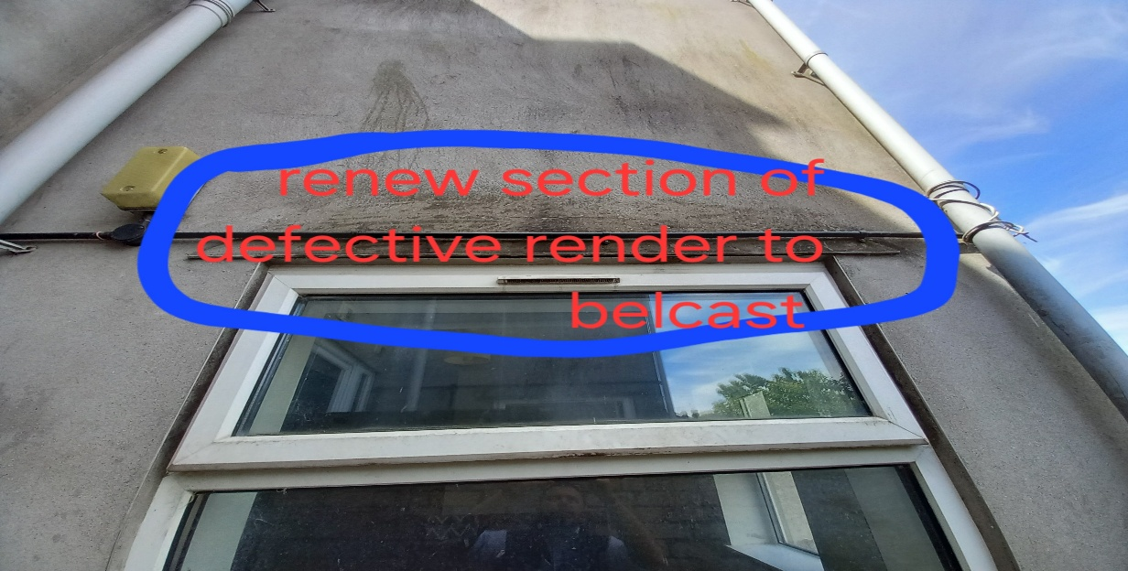
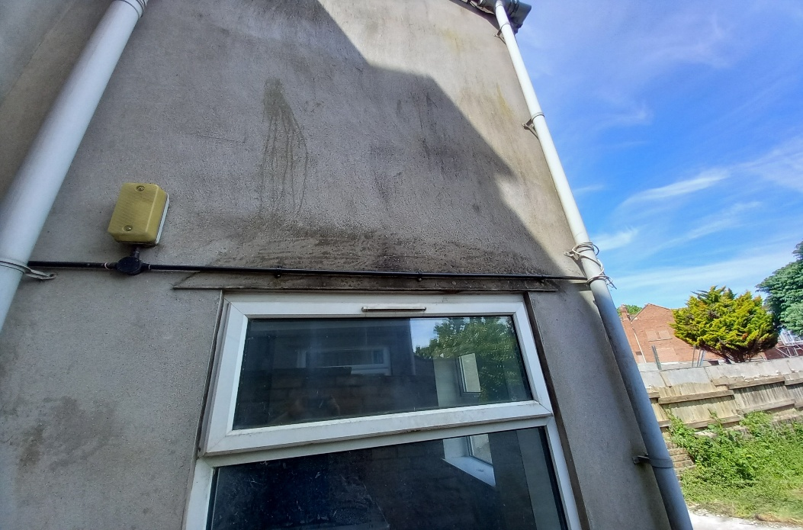

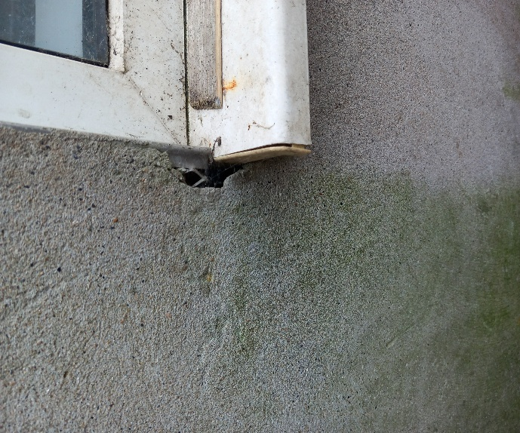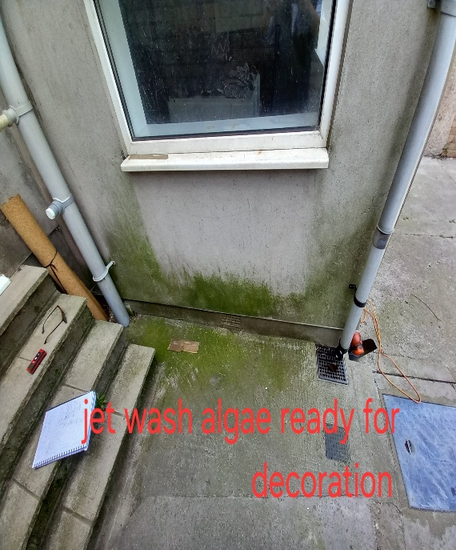

- Hack out and repair sections of render to the rear elevation including filling of redundant holes.
- Apply a silicone bead around the perimeter of both windows.
- Power wash down algae and leave ready for decorations.

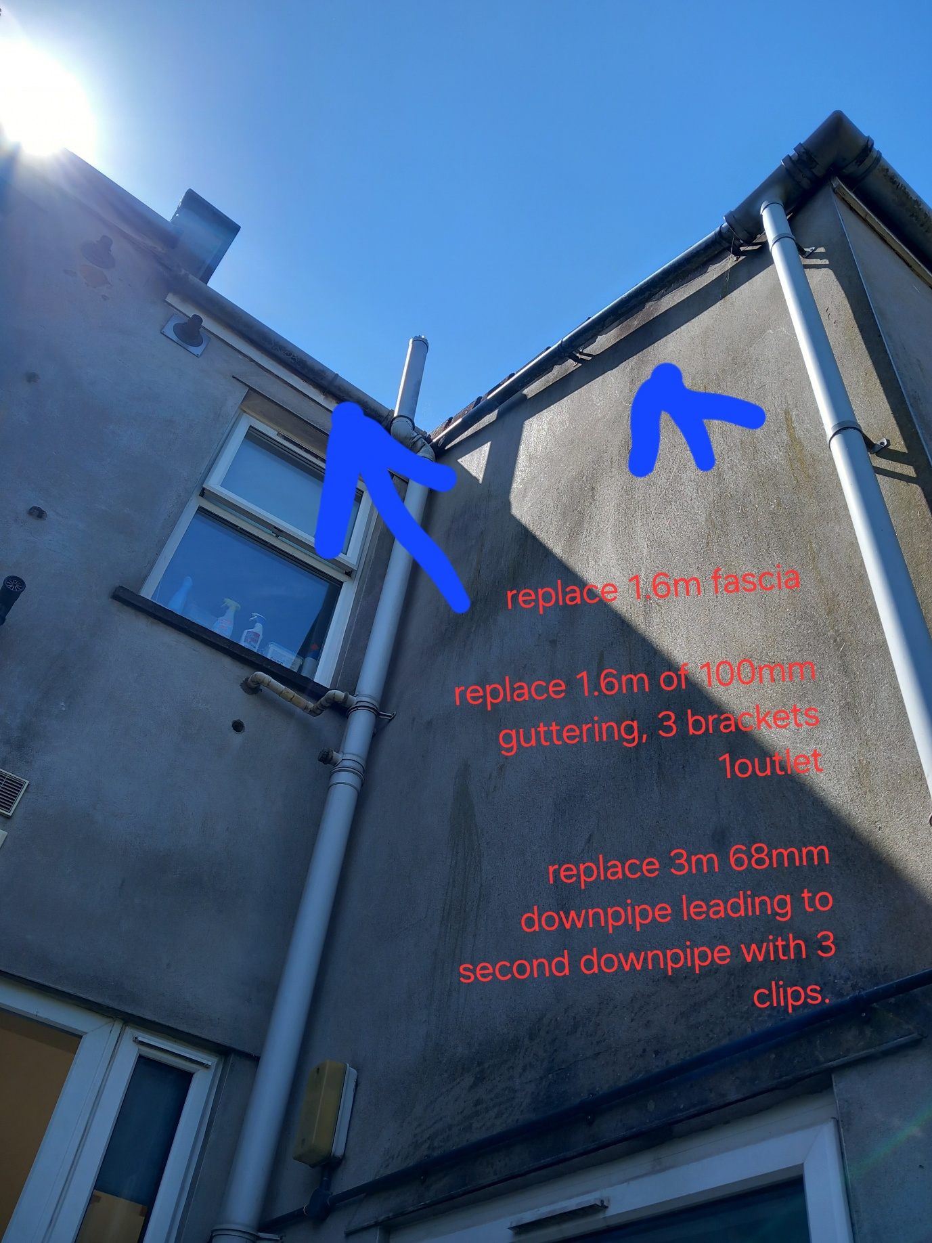

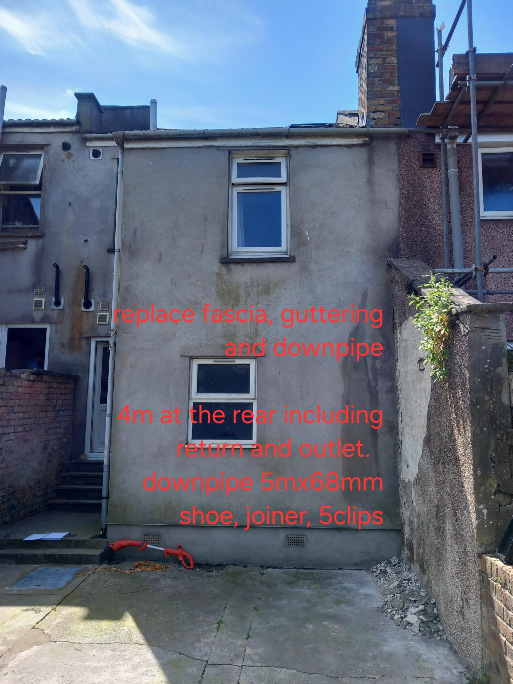
- Replace fascia
- Replace rainwater goods and fittings

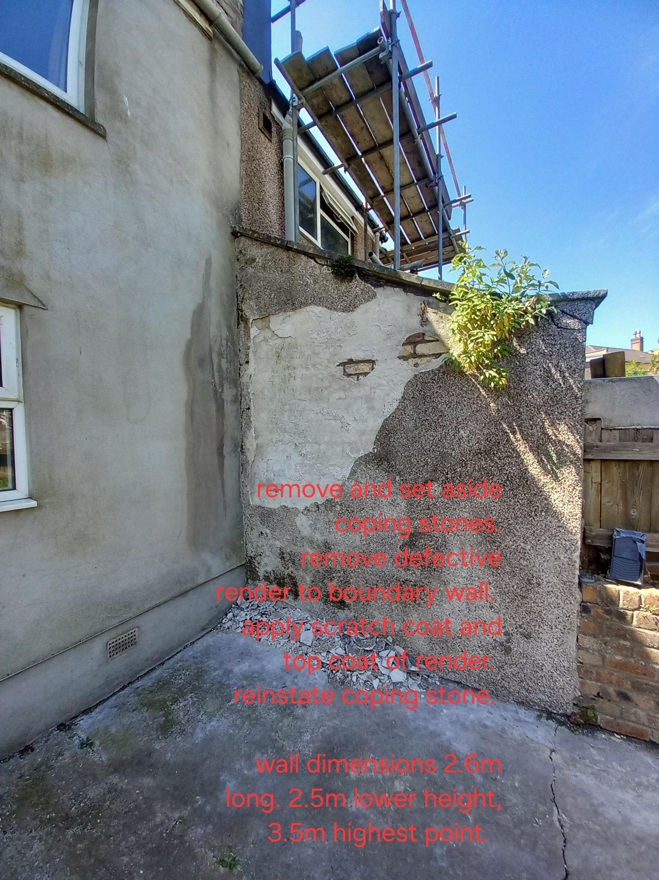
- Remove and set aside coping stones
- Hack off render to Livewest side.
- Apply scratch coat and top coat
- Leave ready for cyclical decorations.
