14 carter walk

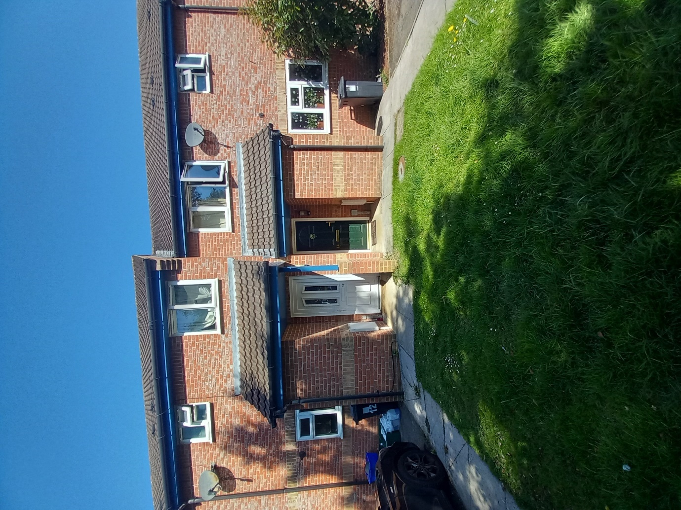

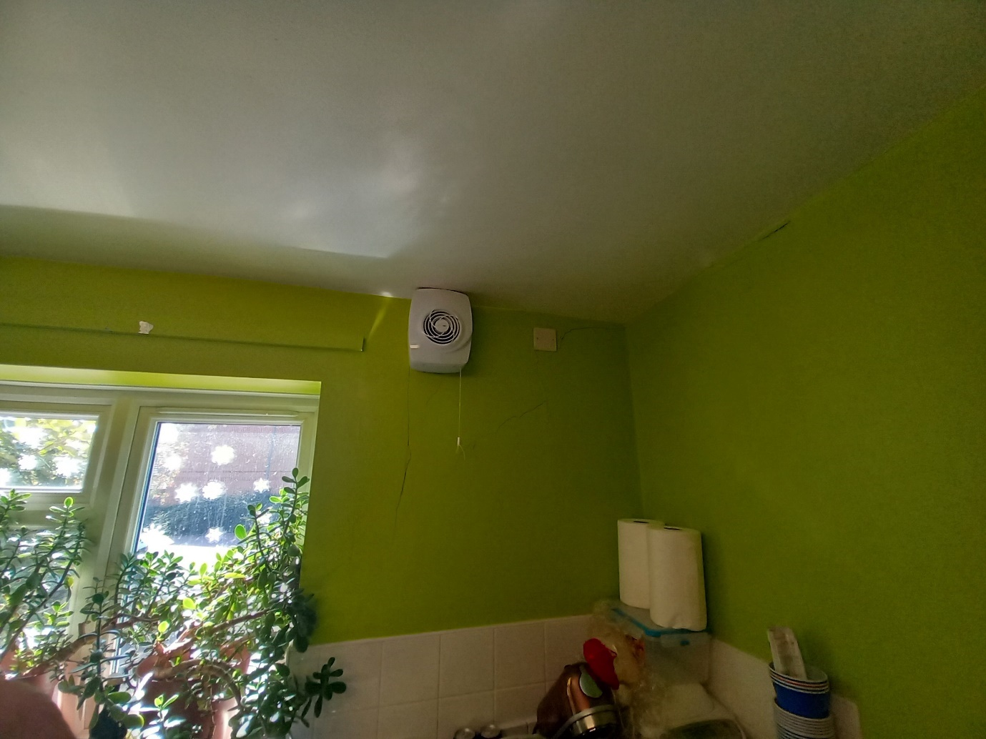

Kitchen

* Isolate, disconnect and set aside extractor fan.
* Hack off plaster back to blockwork to edge of window revel. (approx. 6sm)
* Install helifix bars through mortar joints and overlay blockwork with a brick reinforming mesh to help support thermal movement.
* Dub out and apply 2 coats of plaster finish.
* Prepare hairline movement cracks to wall and ceiling lines with a flexible decorators sealant.
* Decorate all walls to match best as possible. https://www.dulux.co.uk/en/colour-details/lime-zest-1
* Rake and reseal window board.
* Reinstate extractor fan.

Approx. room size 30sm.

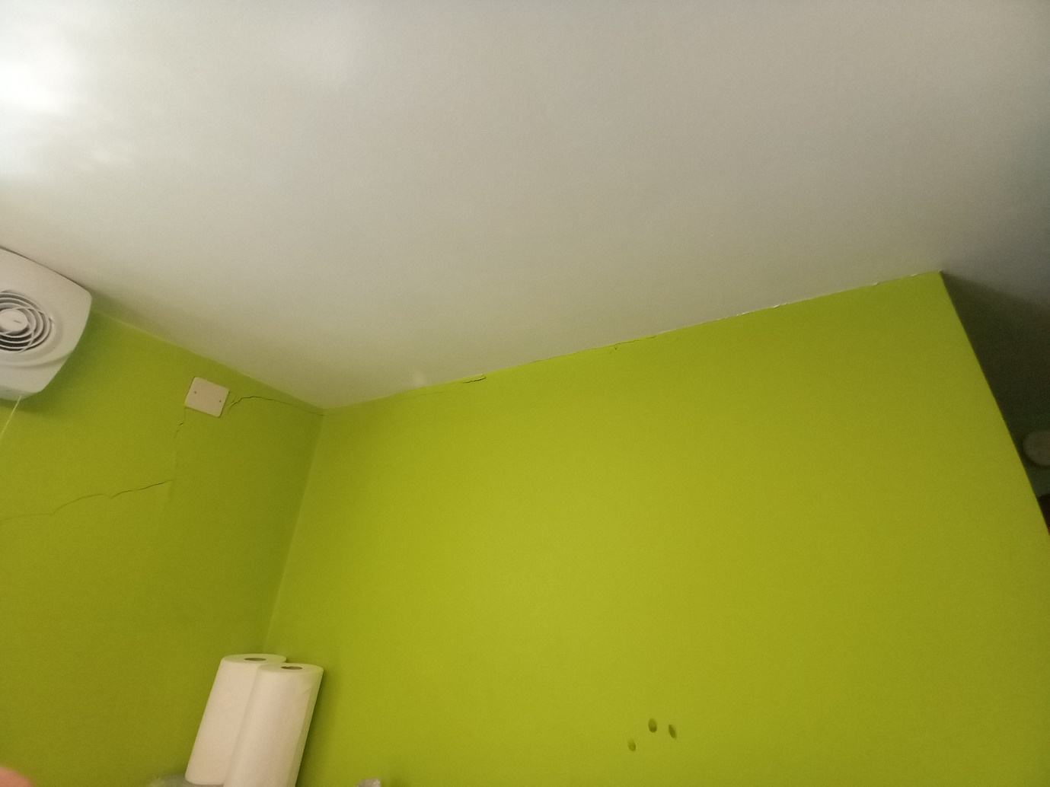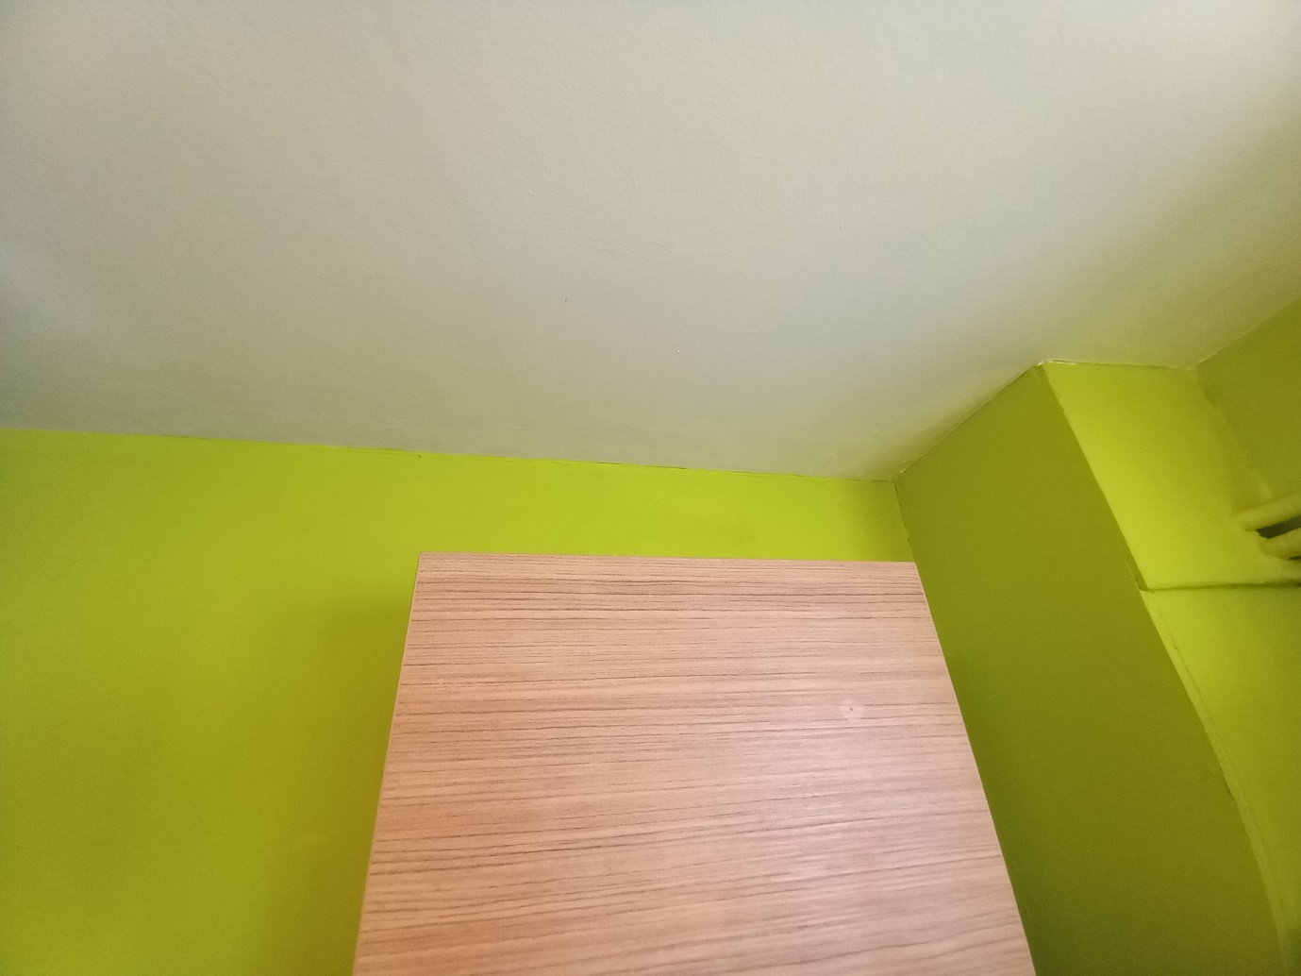

Lounge

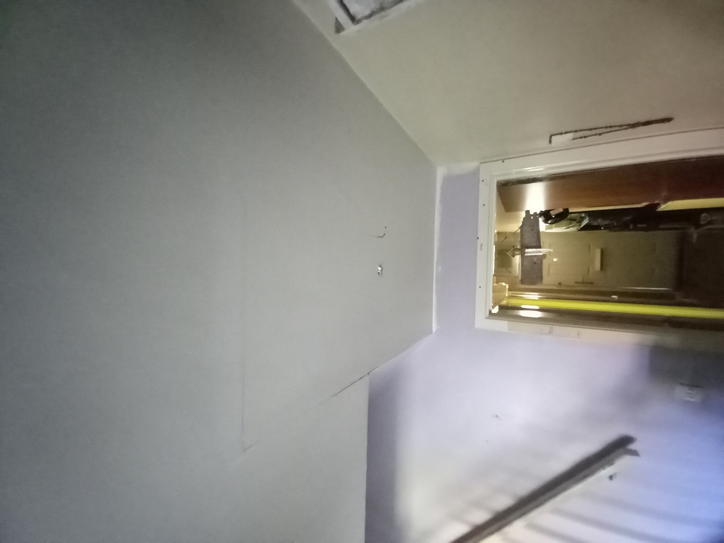

* Hack plaster back to blockwork on half of back wall. (approx. 10sm)
* Install helifix bars and brick reinforming mesh to mortar and blockwork around the damaged sections.
* Dub out and apply 2 coats of plaster.
* Apply 1 coat of mistcoat and 2 top coats of magnolia
* Prepare crack to ceiling by stairs and touch in decorations.

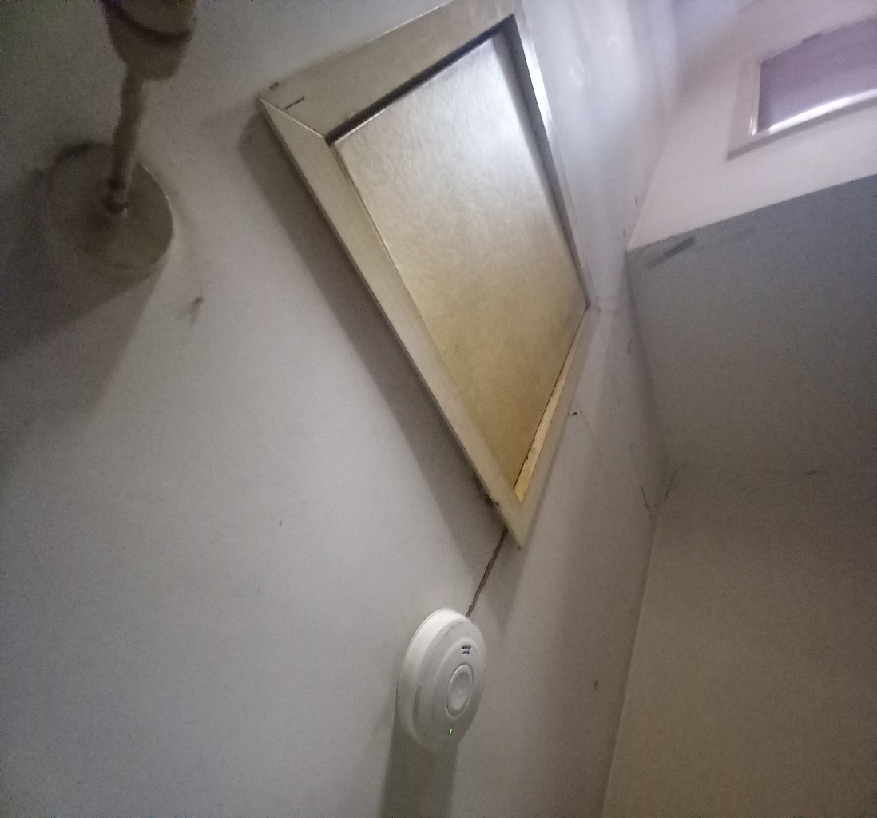

Stairs and landing (approx. 12sm)

* Replace loft hatch
* Re-fix plasterboard back to joists
* Prepare and smooth out repair joints.
* Decorate ceiling in white emulsion.

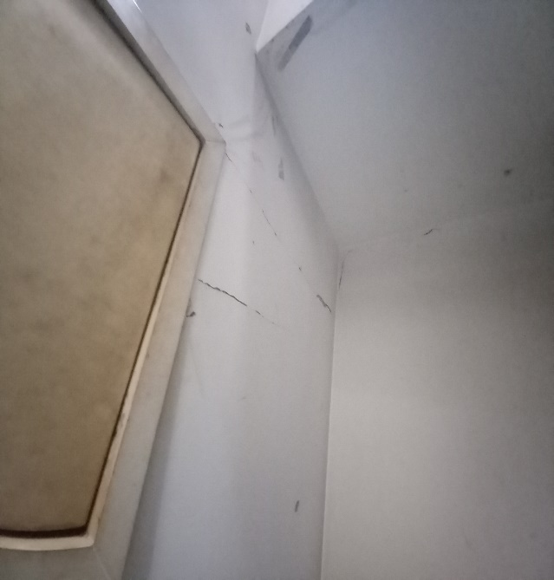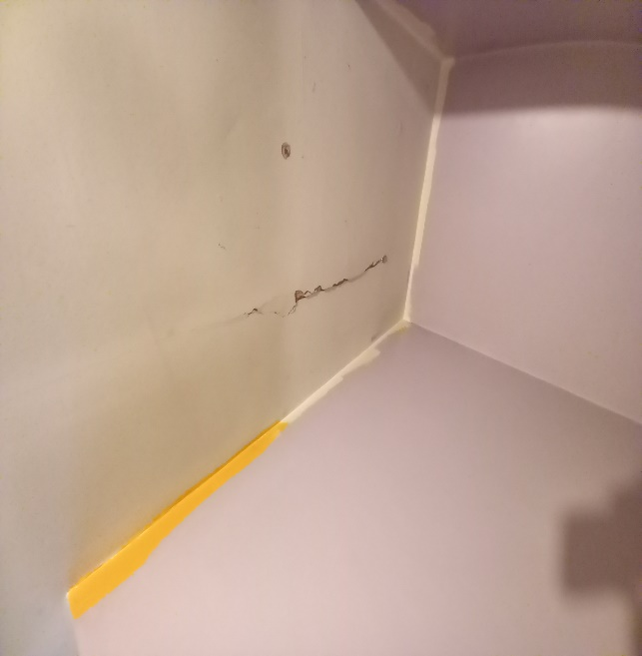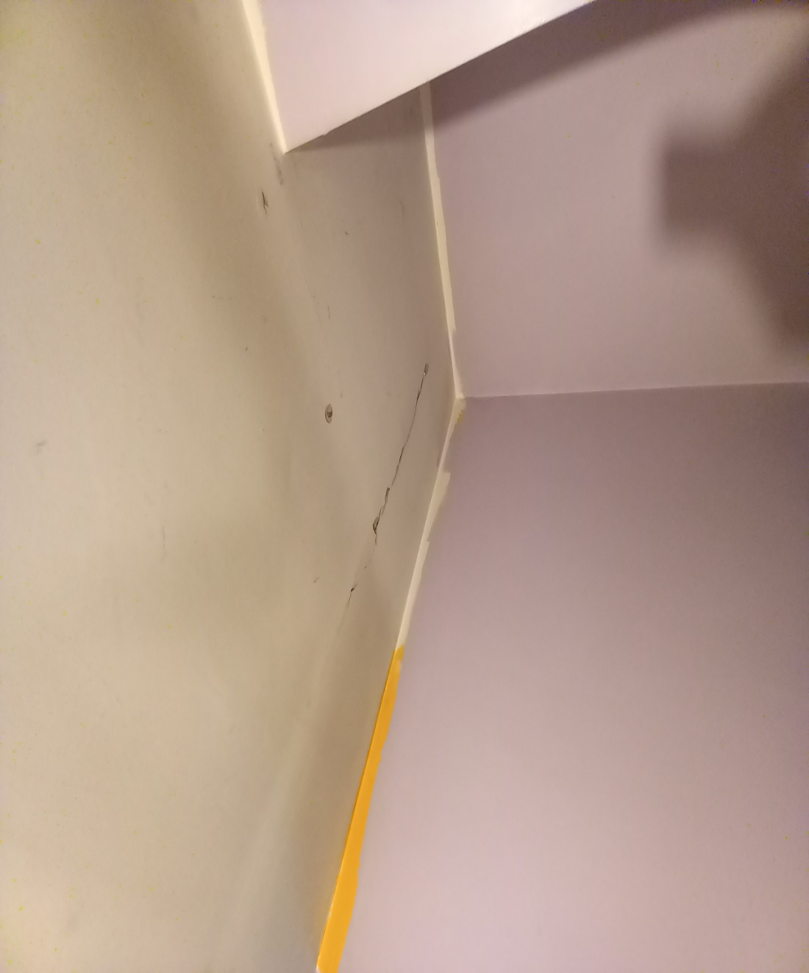

Front Bedroom

* Disconnect radiator and set to one side.
* Hack off plaster back to blockwork to window wall and R/H wall. (approx. 24sm)
* Install helifix bars and brick reinforming mesh to mortar and blockwork around the damaged sections.
* Dub out both walls and apply 2 coats of multi finish plaster.
* Apply mistcoat to fresh plaster and 2 coats of magnolia.
* Reinstate radiator

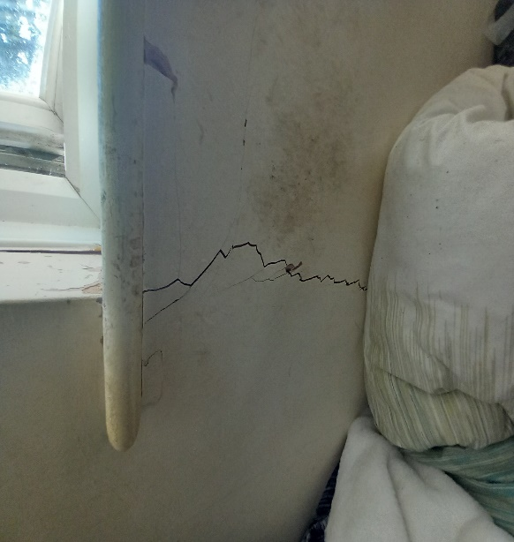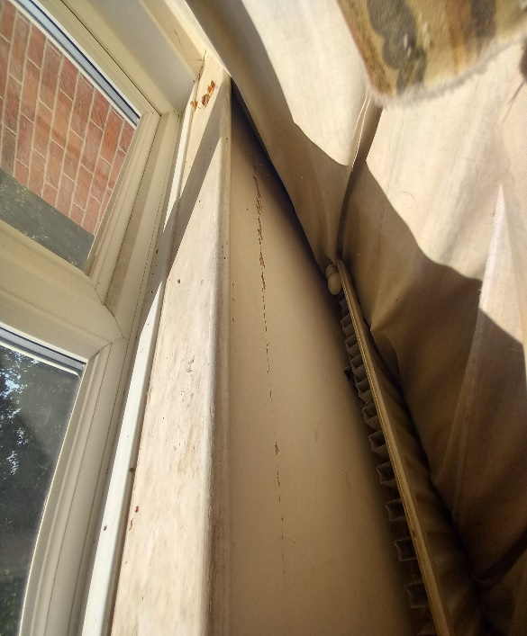

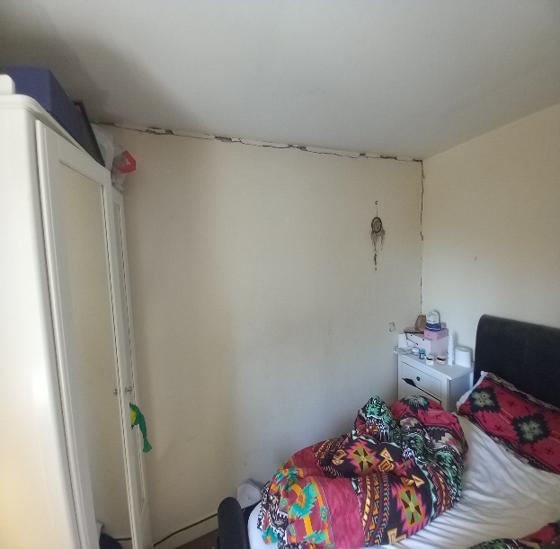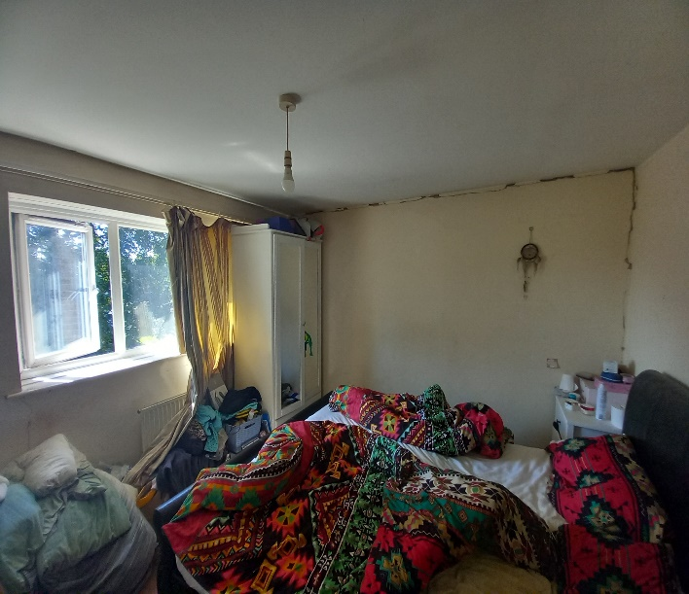

Back Bedroom

* Disconnect radiator and set to one side
* Hack off plaster back to blockwork to window wall and R/H wall. (Approx. 24sm)
* Install helifix bars and brick reinforming mesh to mortar and blockwork around the damaged sections.
* Dub out both walls and apply 2 coats of multi finish plaster.
* Apply mistcoat to fresh plaster and 2 coats of magnolia.
* Reinstate radiator

